Start screen:

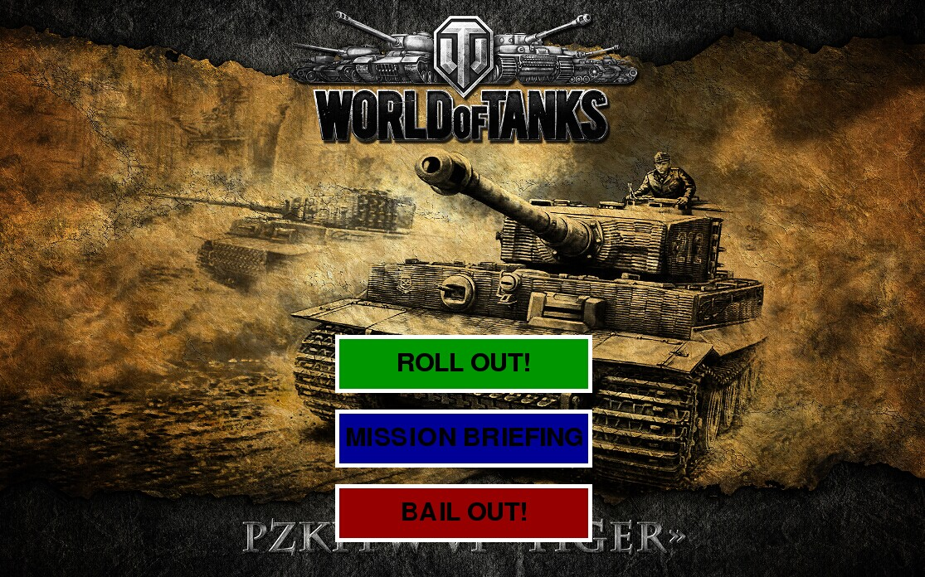

Player can start playing here, see help screen and what to do in this game, or quit the game.

Help screen:

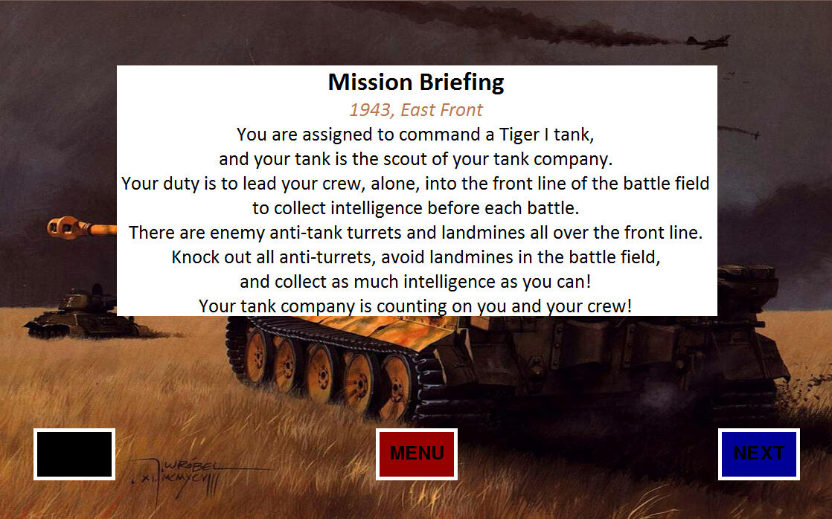

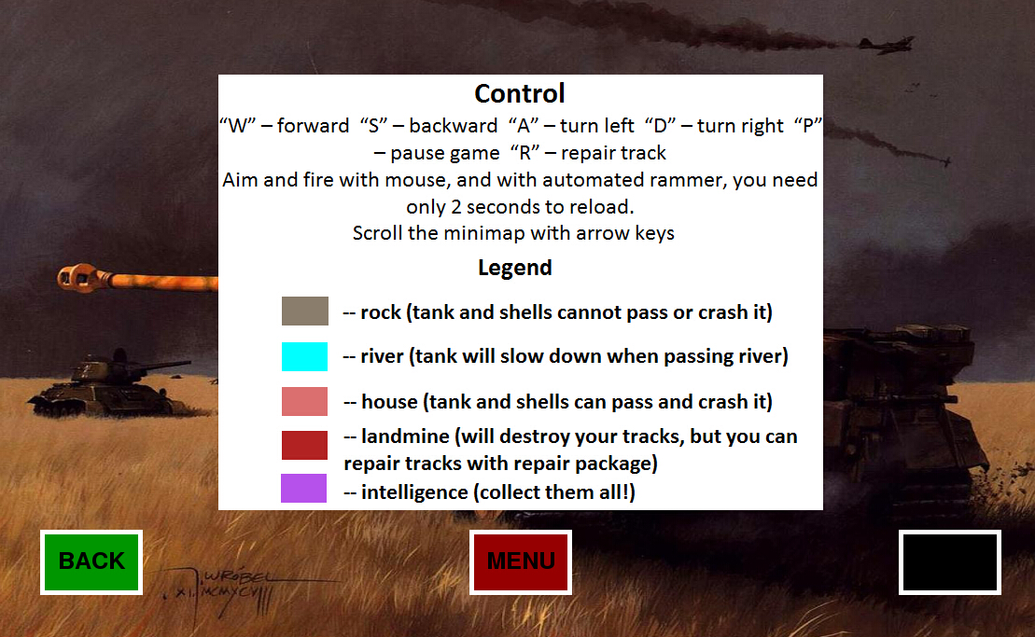

There are two pages: the first on explains what the player should do in this game; the second one explains how to control the tank and other features.

Map Selection:

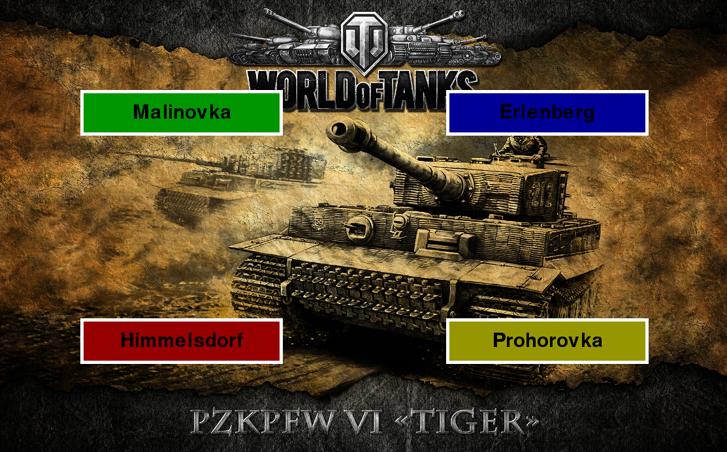

Player can select a map to play on this screen.

Game screen:

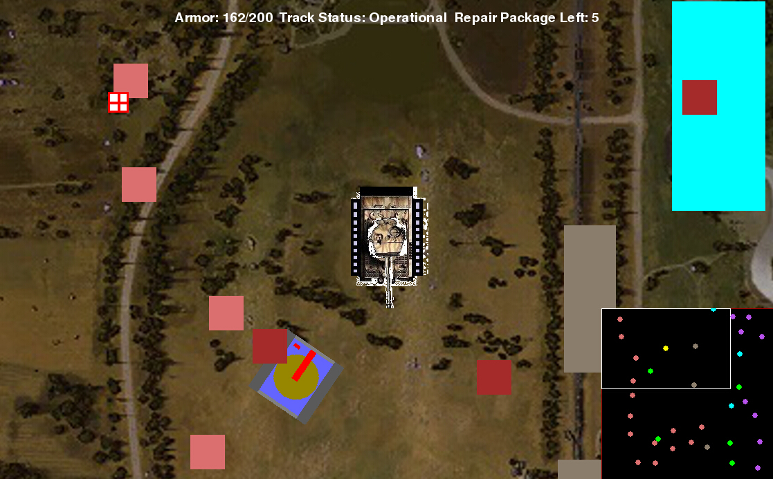

The game looks like this: squares with different colors are different objects: house, rock, river, landmine, intelligence, and enemy turret. The minimap is on the right-down corner. The player status is on the top of the screen.